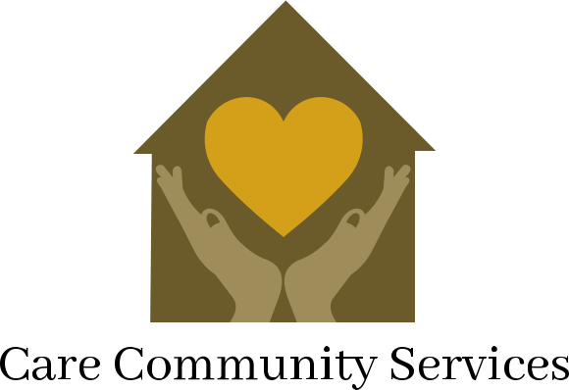
Parent Support Outreach Program Application Form

Program Description
The Parent Support Outreach Program strives to provide support services to Ramsey County families with children.

Primary Caregiver Information:
Family and Community Partnership 160 Kellogg Blvd. E. Saint Paul, MN 55101
Phone: 651-266-4882
651.266-4895
Fax: 651-266-3702

Name
Date / /

last name first name middle initial social security #
month
day year

Birthdate / /
month day year
Gender: Male Female Primary Language

Address ____________ __________________________
Phone Number

Do you need an interpreter? yes, No Signature ____________________________

Secondary Caregiver Information:
Name
last name first name middle initial
Birthdate / /
Gender: Male Female Primary Language

month
day year

Child name / | Gender (M/F) | Date of birth (M/D/Y)

Check any or all that apply to your situation:
Emotional or behavioral concerns
Substance abuse
Mental health concerns
Experienced child abuse
Experienced domestic abuse
History Experienced homelessness

Area(s) your family needs assistance with:

To be filled out by staff: |  | Referring source information:
SSIS cleared Yes, No Date  Date received / /  Intake worker ______________________________ |  | Referral agency  Staff name  Agency phone Agency fax Staff email  Referent notified Yes No

Revised: August, 2018

